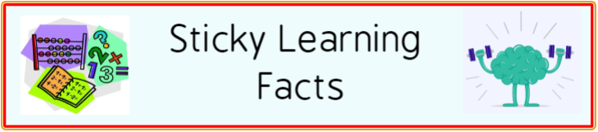
To develop your child’s fluency and mental maths skills, we are introducing key instant recall facts called ‘Sticky Learning Facts’ throughout school. These are a way of helping your child to learn by heart, key facts and information which they need to have instant recall of.
Sticky Learning Facts are designed to support the development of mental maths skills that underpin much of the maths work in our school. They are particularly useful when calculating, adding, subtracting, multiplying or dividing. They contain number facts such as number bonds and times tables that need constant practise and rehearsal, so children can recall them quickly and accurately.
Instant recall of facts helps enormously with mental agility in maths lessons. When children move onto written calculations, knowing these key facts is very beneficial. For your child to become more efficient in recalling them easily, they need to be practised frequently and for short periods of time.
Each half term, children will be given Sticky Learning Facts to practise and learn at home for the half term. They will also be available on our school website on each Class page and each child will receive a copy to keep at home. The Sticky Learning Facts include practical ideas to assist your child in grasping the key facts and contain helpful suggestions of ways in which you could make this learning interesting and relevant. They are not designed to be a time-consuming task and can be practised anywhere – in the car, walking to school, etc. Regular practice - little and often – helps children to retain these facts and keep their skills sharp.
Over their time at primary school, we believe that - if the Sticky Learning Facts are developed fully - children will be more confident with number work, understand its relevance, and be able to access the curriculum much more easily. They will be able to apply what they have learnt to a wide range of problems that confront us regularly.
Year 1 – Autumn 2

To explore and identify part and whole.
To recognise and name one half.
To recognise and name one quarter.
By the end of this half term, children should be able to recall the following facts. The aim is for them to recall these facts instantly.
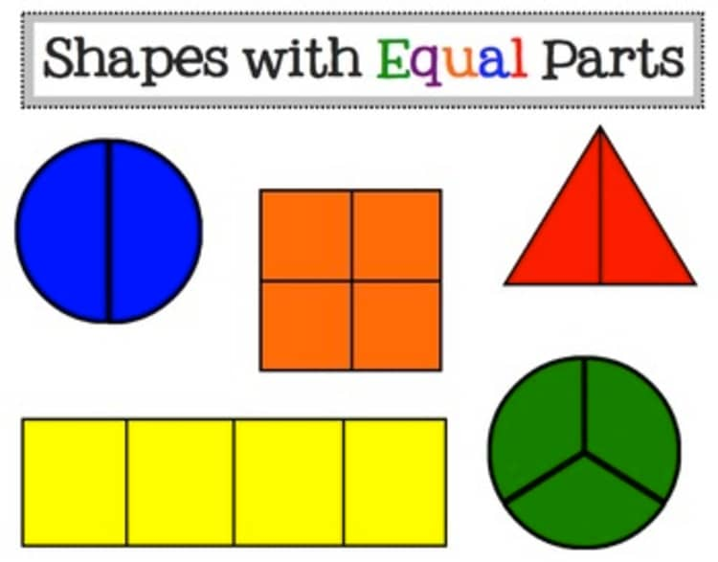
Key Vocabulary
Part
Whole
Half
Quarter
Equal
Numerator
Denominator

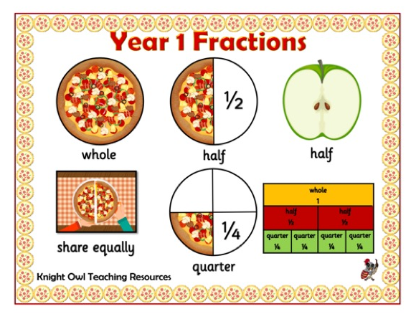
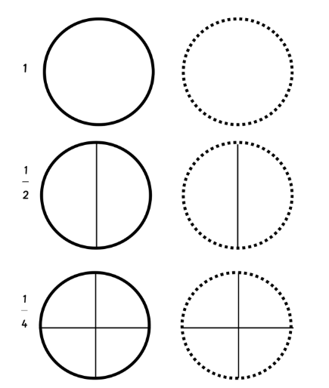

Children should be able to recall facts instantly and be able them to use their knowledge in a variety of contexts.
Top Tips – As always, the secret to success is practising little and often. Use time wisely. Can you practise these facts whilst walking to school or during a car journey? You do not need to practise them all at once; perhaps you could have a fact of the day. If you would like more ideas, please speak to your child’s teacher.
Play games
https://www.bbc.co.uk/bitesize/topics/z3rbg82
https://www.topmarks.co.uk/Search.aspx?q=fractions+ks1

